DBS Code Assignment – MYCACHE (IN-MEMORY CACHING LIBRARY)

Author: Sudhan Balaji Sridharan
Date: 21.05.2020

PROBLEM STATEMENT:

It’s 2008 all over again and Redis have not been invented yet. Your task, should you choose to accept is
to design a caching library from scratch for the entire world to use (as redis would have become).

What is expected of you is to come up with a first deliverable after about 2 hours of work. You are free
to do any necessary research on the internet as with real task.

We do not expect you to complete all the features but at the bare minimum, it should have basic
caching functionalities.

Write the code with the intention of announcing your pet project on twitter, Hackernews or reddit to
encourage contributors (as redis author did way back in 2009 https://redislabs.com/blog/redis-turns-
10/).
Deliverables:
• Git bundle of your solution
• Documentation of design considerations &amp; trade-offs taken
Constraints:
You may only use Java 1.8+ / Kotlin

Mycache – PROJECT DESCRIPTION

MYCACHE – What it offers?
- Lightweight Java Object cache API
- Thread Safe In-Memory Cache

MYCACHE – What it doesn’t offer?
- In-Memory Caching for Distributed applications
- Performance on large applications

PROGRAM DIVE-IN:
- MyCache requires the below parameters for Caching an object
  - Cache Expiry Time (in seconds)
  - Cleanup Time Interval (in seconds)
  - Maximum Elements to be stored in the Cache (int)

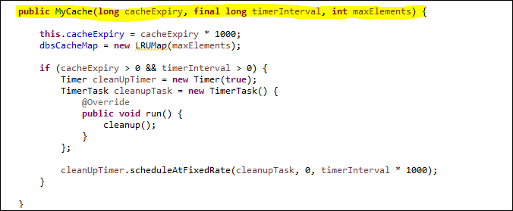

- Cache Objects will expire based on the Cache Expiry Time
- Using LRUMap (apache commons collections) – Removes least used entries in a fixed size map. This serves the purpose of removing least used elements when maxElements size is reached.

- For the expiration of cache objects, we timestamp the last access and in a separate thread remove the items when the time to live limit is reached. This serves the purpose of reducing memory for applications that have long idle time in between accessing the cached objects.

MYCACHE TESTING – SCREENSHOT

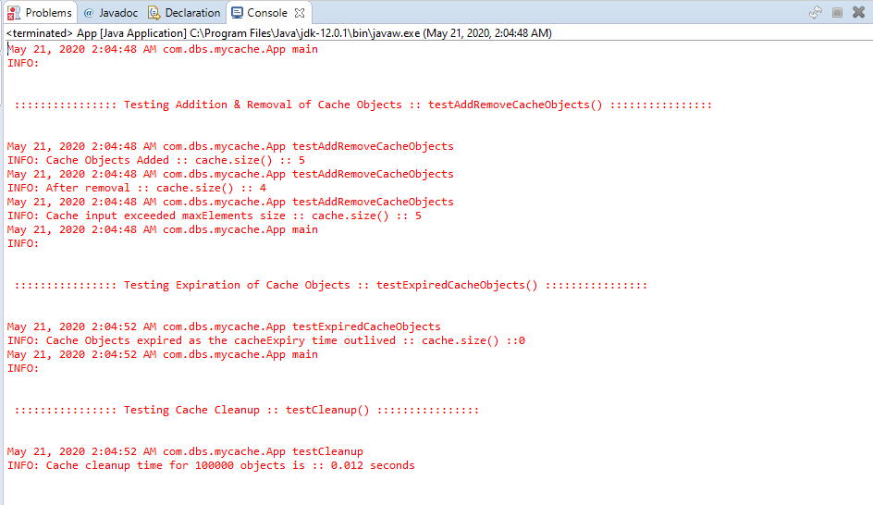

MYCACHE – github link
https://github.com/sudhanbalaji23/dbs-mycache

